GEOMETRY A /GEOMETRY B SUMMER HOMEWORK

*Welcome to Geometry! We look forward to meeting you in a few months. Below are the skills you learned this year in Algebra 1 that are necessary for success in Geometry A. Please answer all of the following questions on a SEPARATE PIECE OF PAPER. If you have any questions or need help feel free to email any of us.

Enjoy your summer,
The Geometry A and Geometry B Teachers

SOLVE THE EQUATION (SHOW YOUR WORK)

1.) 2.) 3.)

4.) 5.) 6.)

7.) 8.) 9.)

10.) 11.) 12.)

13.) 14.) 15.)

16.) 17.) 18.)
19.) 20.)

21.) 22.) 23.)

SIMPLIFY EACH EXPRESSION BY FOILING (Double Distribution)

24.) 25.)

26.) 27.)

USE THE QUADRATIC FORMULA TO SOLVE EACH EQUATION

28.) 29.)

30.) 31.)

FINDING AREAS OF FIGURES
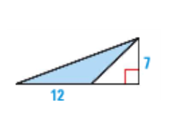
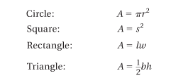
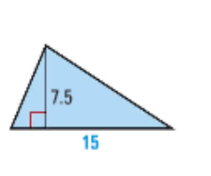
32.) 33.)

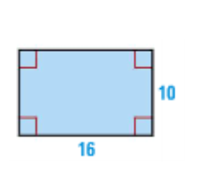
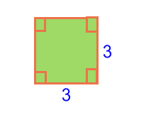

34.) 35.)

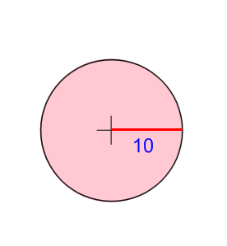
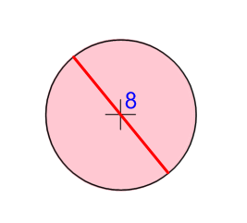
36.) 37.)

Graph the following equation.

38.) 39.)
40.) 41.)

Write an equation in slope – intercept form of the line that passes through the given 2 points.

42.) (1 , 2) (3 , -2) 43.) ( 0 , -3) ( - 5 , 0)

Simplify the fractions.
44.) 45.) 46.)

47.) 48.) 49.)

50.) 51.) 52.)

Solve the following Systems by Substitution:

53.) 54.)

55.) 56.)
Solve the following Systems by Elimination:

57.) 58.)

59.) 60.)

Cross Multiplication:

61.) 62.) 63.)

64.) 65.) 66.)

